**Lab Report 02**

*Course title: Computer Graphics Laboratory*

*Course code: CSE-304*

*3rd Year 1st Semester 2022*

**Date of Submission**: 04/06/2023



###### **Submitted to-**

###### Dr. Mohammad Shorif Uddin

###### Professor

*Department of Computer Science and Engineering*

*Jahangirnagar University*

*Savar, Dhaka-1342*

*And*

*Dr. Morium Akter*

###### Associate Professor

*Department of Computer Science and Engineering*

*Jahangirnagar University*

*Savar, Dhaka-1342*

|  |  |  |  |
| --- | --- | --- | --- |
| **Sl** | Class Roll | Exam Roll | Name |
| 01 | 349 | 202161 | Subarna Saha |

**Experiment No.: 1**

**Experiment Name:** Scan conversion of a circle using Midpoint algorithm.

**Source code in C:**

#include <stdio.h>

#include<math.h>

#include <graphics.h>

void drawMidPoint(int xc, int yc, int radius)

{

int x = 0;

int y = radius;

int p = 1 - radius;

while (x<=y)

{

putpixel(xc + x, yc + y, YELLOW);

putpixel(xc - x, yc + y, YELLOW);

putpixel(xc + x, yc - y, YELLOW);

putpixel(xc - x, yc - y, YELLOW);

putpixel(xc + y, yc + x, YELLOW);

putpixel(xc - y, yc + x, YELLOW);

putpixel(xc + y, yc - x, YELLOW);

putpixel(xc - y, yc - x, YELLOW);

if (p<0)

{

p = p+ 2*x+ 3;

}

else

{

p =p+2*(x-y)+5;

y--;

}

x++;

}

}

int main()

{

int xc, yc, radius;

printf("Enter the coordinates of the center of the circle: ");

scanf("%d %d", &xc, &yc);

printf("Enter the radius: ");

scanf("%d", &radius);

int gd = DETECT, gm;

initgraph(&gd, &gm, (char*)"");

drawMidPoint(xc, yc, radius);

delay(5000);

closegraph();

return 0;

}

**Input and Output:**

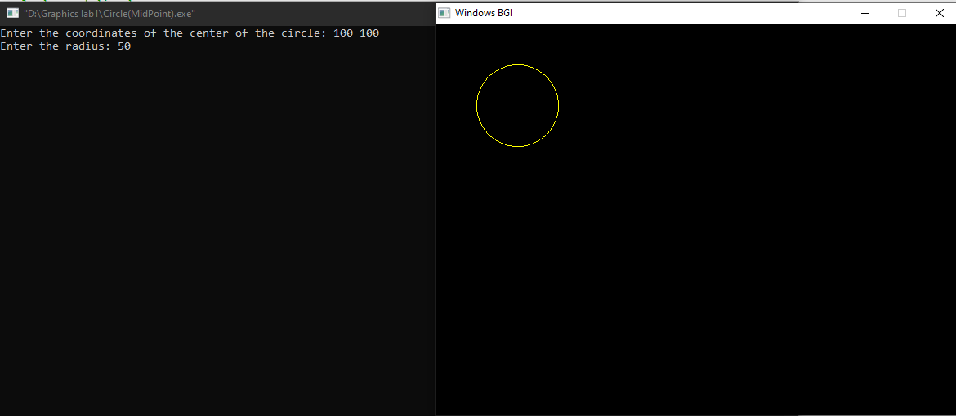

**Experiment No.: 2**

**Experiment Name:** Scan conversion of an ellipse using Midpoint algorithm

**Source code in C:**

#include <stdio.h>

#include<math.h>

#include <graphics.h>

void drawEillpseMidPoint(int xc, int yc, int a, int b)

{

int x = 0;

int y = b;

int aa=a*a, bb=b*b;

int aa2=aa*2, bb2=bb*2;

int fx=0, fy=aa2*y;

int p= bb - aa*b +0.25*aa;

while (fx<=fy)

{

putpixel(xc + x, yc + y, YELLOW);

putpixel(xc - x, yc + y, YELLOW);

putpixel(xc + x, yc - y, YELLOW);

putpixel(xc - x, yc - y, YELLOW);

x++;

fx=fx+bb2;

if (p<0)

{

p = p+ fx +bb;

}

else

{

y--;

fy=fy-aa2;

p = p+ fx +bb-fy;

}

}

putpixel(xc + x, yc + y, YELLOW);

putpixel(xc - x, yc + y, YELLOW);

putpixel(xc + x, yc - y, YELLOW);

putpixel(xc - x, yc - y, YELLOW);

p= bb*(x+0.5)*(x+0.5) + aa*(y-1)*(y-1) - bb*aa;

while (y>=0)

{

y--;

fy=fy-aa2;

if (p>=0)

{

p = p- fy +aa;

}

else

{

x++;

fx=fx+bb2;

p = p+ fx -fy +aa;

}

putpixel(xc + x, yc + y, YELLOW);

putpixel(xc - x, yc + y, YELLOW);

putpixel(xc + x, yc - y, YELLOW);

putpixel(xc - x, yc - y, YELLOW);

}

return;

}

int main()

{

int xc, yc, radius,a,b;

printf("Enter the coordinates of the center of the ellipse: ");

scanf("%d %d", &xc, &yc);

printf("Enter the length of the major axis: ");

scanf("%d", &a);

printf("Enter the length of the minor axis: ");

scanf("%d", &b);

int gd = DETECT, gm;

initgraph(&gd, &gm, (char*)"");

drawEillpseMidPoint(xc, yc, a, b);

delay(5000);

closegraph();

return 0;

}

**Input and Output:**

